

|  |  |
| --- | --- |
|  | **VIỆN ĐÀO TẠO QUỐC TẾ FPT**  LẬP TRÌNH VIÊN QUỐC TẾ FPT – APTECH |

****Star Security Services****

PROJECT DOCUMENTATION SEM 3

|  |  |  |
| --- | --- | --- |
| **Supervisor:** | *HOÀNG ĐỨC QUANG* | |
| **Semester:** | *03* | |
| **Batch No:** | T1.1810.E0 | |
| **Group No:** |  | |
| **Order:** | **Full name** | **Roll No.** |
| 1. | Lê Hữu An | **Student 1151445** |
| 2. | **Nguyễn Hải Long** | **Student 1151437** |
| 3. | **Nguyễn Đình Kiên** | **Student 1148305** |
| 4. | **Cao Đặng Xuân Dương** | **Student 1151426** |

**January- 2020**

 

This is to certify that

**Mr. LE HUU AN**

**Mr. NGUYEN HAI LONG**

**Mr. NGUYEN DINH KIEN**

**Mr. CAO DANG XUAN DUONG**

Have successfully Designed & Developed

**Star Security Service**

Submitted by:

**HOANG DUC QUANG**

Date of Issue:

Authorized Signature:



# Acknowledgement

We would like to express our gratitude to our teachers, who teach us a lot of knowledge and practical lessons. He helped us so much in this project. Thank you!

We also would like to express our sincere thanks towards the members of the team who spent their time and knowledge in the implementation of this project.

# Problem Definition

Our client is a professional agency providing customized security arrangements to the industrial, commercial, and business houses included: manned guarding, cash services, recruitment and training, electronic security systems.

To bring the Automation in the system and to cope up in this competitive world, our client want to incorporate an online system to ensure a well-trained personel so as to relieve their clients of all vexations and bothers appertaining to their safety, security and management.

**Identify The Problem:**

* Display brief information about Star Security.
* Display all available Star’s services to customers.
* Customers can contact with Star Security about all offered services via website
* Supporting administrators with the ability to update information quickly and accurately.
* Supporting administrators to manage employees.

**Customers:**

* Can get information about security services.
* Can contact the administrator.

**Admin:**

* Add/update/delete/edit the details of the employees.
* Add/update/delete/edit vacancies.
* Add/update/delete/edit services offered.
* Add/update/delete/edit clients details.

# Customer Requirements Specification

**Guest:**

Inserting:

* Information about the chosen services.
* Getting contact to administrators.

Processing:

* Searching information about services.

**Admin:**

Inserting:

* Information about signing of admin.
* Information about services offered need to insert, delete or edit.
* Information about the details of employees need to insert, delete or edit.
* Information about vacancies need to insert, delete or edit.
* Information about clients details needs to insert, delete or edit.

Processing:

* Create New Employee.
* Inserting/Deleting/editing services offered.
* Inserting/Deleting/editing details of employees.
* Inserting/Deleting/editing vacancies.
* Inserting/Deleting/editing clients details.
* Reply to customer contact.

Exporting:

* Notification about create new employee success or fail.
* Notification about inserting/deleting/editing services offered successfully or fail.
* Notification about inserting/deleting/editing details of employees successfully or fail.
* Notification about inserting/deleting/editing vacancies successfully or fail.
* Notification about inserting/deleting/editing clients details successfully or fail.

# Hardware/ Software Requirements

**Hardware**

* 1.0 GHz x86 Processor, Pentium III-compatible processor or faster.
* 1.4 GHz x64 Processor, AMD Opteron, AMD Athlon 64, Intel Xeon with Intel EM64T support, Intel Pentium IV with EM64T support or faster.
* 1.0 GB RAM. Recommended 2.0 GHz or faster.
* 2.0 GB of Hard disk free.
* Screen require VGA at least 1024x768 pixel resolution or higher.

**Software**

* Visual Studio .Net / ASP
* IIS server
* .Net Framework
* Java Virtual Machine/ J2EE server
* Notepad/Java editor
* j2sdk1.4.1_02 (or later).
* EJB Dev Kit
* Java enabled web server
* JSP / Servlets Dev. Kit

# Task Sheet Review I

|  |  |  |  |  |  |
| --- | --- | --- | --- | --- | --- |
| Project Ref. No: 1 | Project Title:  Star Security Services System | Date of Preparation of Activity Plan | | | |
| No. | Task | Actual Start Date | Actual Days | Team Member Names | Status |
| 01 | Acknowledgment | Feb 23, 2020 | 4 | All Members | Completed |
| 02 | Problem Definition | All Members | Completed |
| 03 | Customer Requirement | All Members | Completed |
| 04 | Functional Logic | All Members | Completed |
| 05 | Use Case | All Members | Completed |
| 06 | Hardware/Software |  |  | All Members | Completed |

|  |  |  |
| --- | --- | --- |
|  | Prepare By: Group 1 | Approved By: Faculty |
| Date: Feb 26, 2020 | Team Leader  Le Huu An | Mr. Hoang Duc Quang |

# REVIEW II

1. Use case

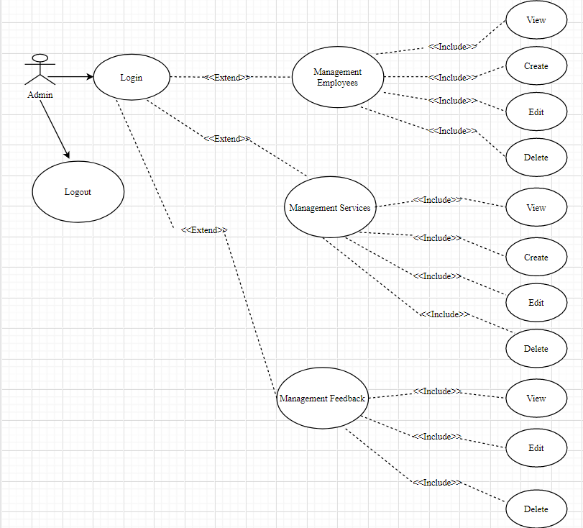**Admin Use Case**

**Employee Use Case**

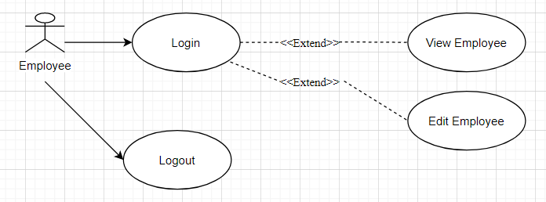

**Customer Use Case**

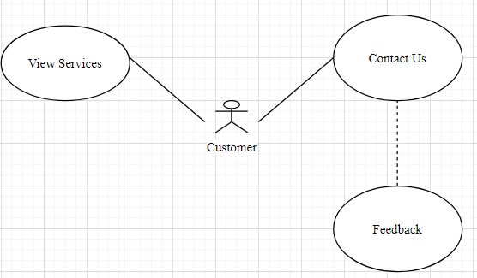

# Architecture & Design of the Project

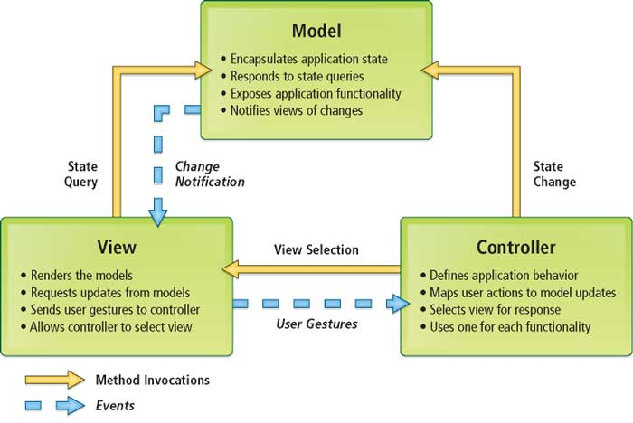

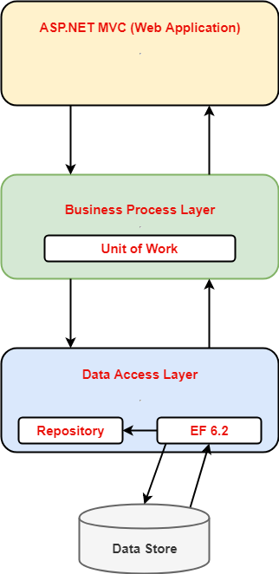

**Architecture of the Project**

1. Presentation Tier:

Is the tier in which the users interact with application. Presentation Tier contents Model, View, Controller used to receive a request and response to User.

Technology: ASP.NET MVC5, Razor, HTML, CSS, JavaScript, Ajax, JQUERY, Twitter Bootstrap

1. Business Logic Tier:

Is mainly working as the bridge between Data Tier and Presentation Tier. All the Data passes through the Business Tier before passing to the Presentation Tier.

Technology: ASP.NET

1. Data Access Tier:

Is basically the server which stores all the application’s data .Data tier contents Database Tables, Database Views and other means of storing Application Data .

Technology: SQL Server, LINQ

**Algorithms - Data Flowchart**

Symbol generates:

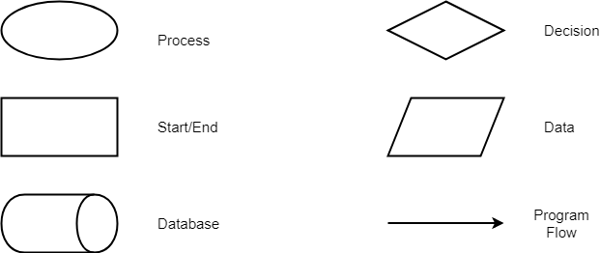

## Login function (Admin, Employee)

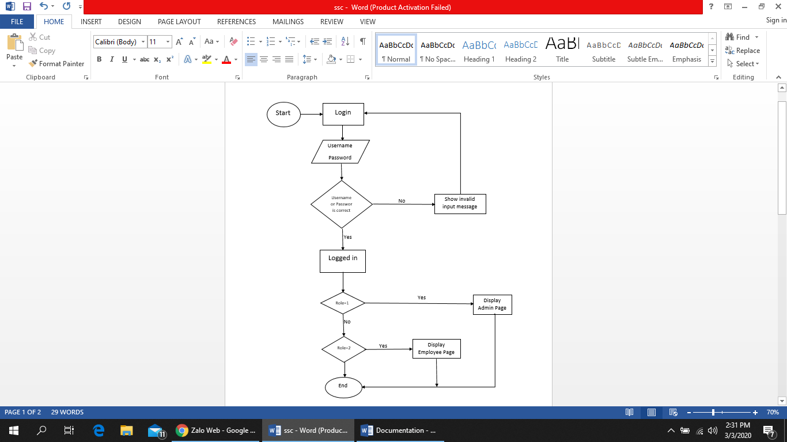

## Logout Function (Admin, Employee)

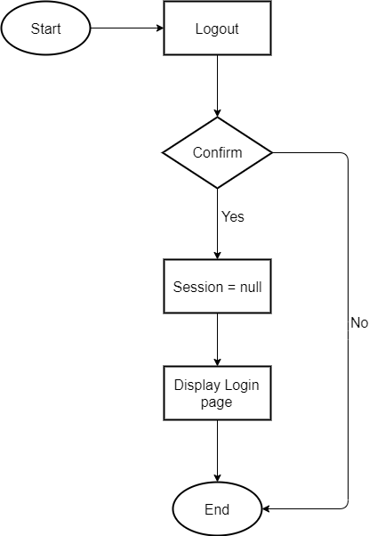

## Create Data Function (Admin Only)

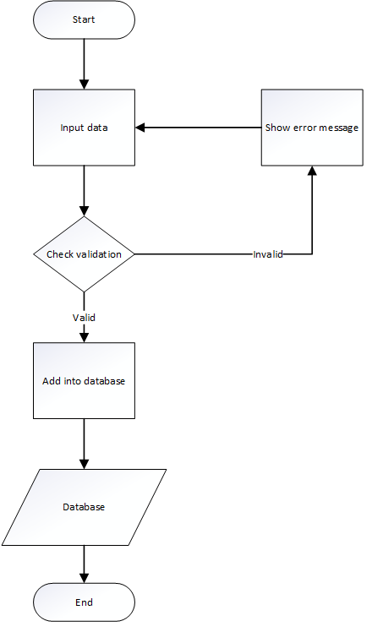

## Edit Data Function (Admin Only)

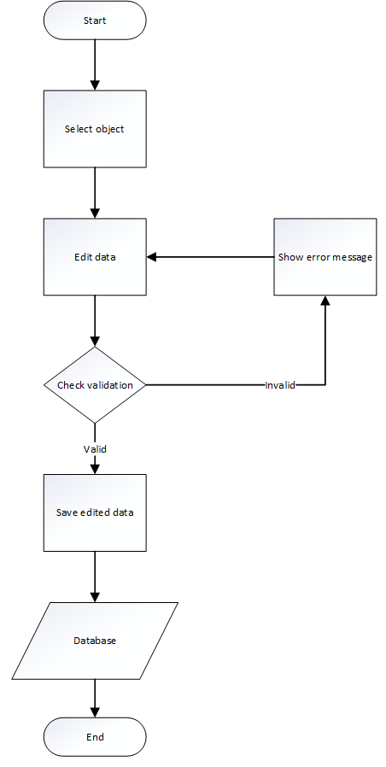

## Delete Data Function (Admin Only)

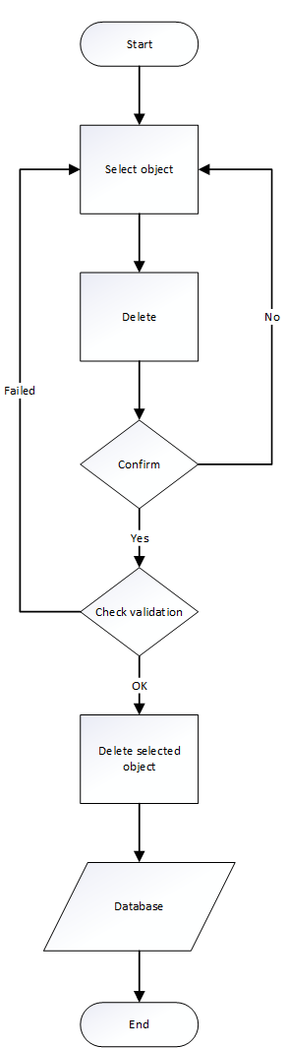

1. Data Flow Diagram

**Define:** Data Flows Diagram (DFD) describes the information flow in the system. The next step of system analysis is to consider in detail the information necessary for the implementation for functions discussed above and the one necessary for the improvement of the functions. Modelling tool frequently used for this purpose is DFD. DFD will support 4 main activities:

* **Analysis**: DFD is used to determine requirement of users.
* **Design:** DFD is used to map out plan and illustrate solution to analysis and users while designing a new system.
* **Communication:** One of the strength of DFD is its simplicity and ease to understand to analysts and users.
* **Document:** DFD is used to provide special description of requirement and system design. DFD provide an overview of key functional components of the system but it does not provide any detail on these components. We have to use other tools like database dictionary, process specification to get an idea of which information will be exchanged and how.

**The main components of Context Diagram:**

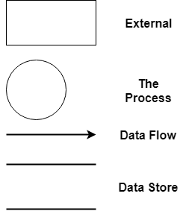

The external factors: External factors can be a person, a group of persons or an organization that are sources of information for the systems and are where system products are transferred to.

The process: Shows the common function of system

The data flow: Describe the movement of information from one part of the system to another.

The data store: The Data Store is used to model a collection of data packets at rest. A store is represented graphically by two parallel lines. The name of a Data Store that identifies the store is the plural of the name of the packets that are carried by flows into and out of the Data Store.

**1 Admin**

**1.1**

Admin

tbEmployee

**1.2 Services Offered Manager**

Admin

tbServices

**1.3 Vacancies Manager**

Admin

tbVacancies

**1.4 Clients Manager**

Admin

tbClients

## **2. Entity-Relationship Diagram**





## **3. Entities and Properties**

* 1. **Employee Entity & Properties**

Employee

* 1. **Clients Entity & Properties**

Clients

* 1. **Vacancies Entity & Properties**

Vacancies

* 1. **Applicants Entity & Properties**

Applicants

* 1. **NetWork Entity & Properties**

NetWork

* 1. **Services Entity & Properties**

Services

* 1. **ServiceType Entity & Properties**

ServiceType

# Task sheet review 2

|  |  |  |  |  |  |
| --- | --- | --- | --- | --- | --- |
| Project Ref. No: 2 | Project Title:  Star Security Services System | Date of Preparation of Activity Plan | | | |
| No. | Task | Actual Start Date | Actual Days | Team Member Name | Status |
| 01 | Architecture & Design of the Project | Feb 26, 2020 | 6 | All Members | Completed |
| 02 | Algorithms - Data Flowchart | Le Huu An | Completed |
| 03 | Data Flow Diagram | Nguyen Hai Long | Completed |
| Nguyen Dinh Kien | Completed |
| 04 | ERD | Cao Dang Xuan Duong | Completed |

|  |  |  |
| --- | --- | --- |
|  | Prepare By: Group 1 | Approved By: Faculty |
| Date: Mar 02, 2020 | Team Leader  Le Huu An | Mr. Hoang Duc Quang |

# REVIEW III

1. **Database Design**
2. **Database Design Diagram**

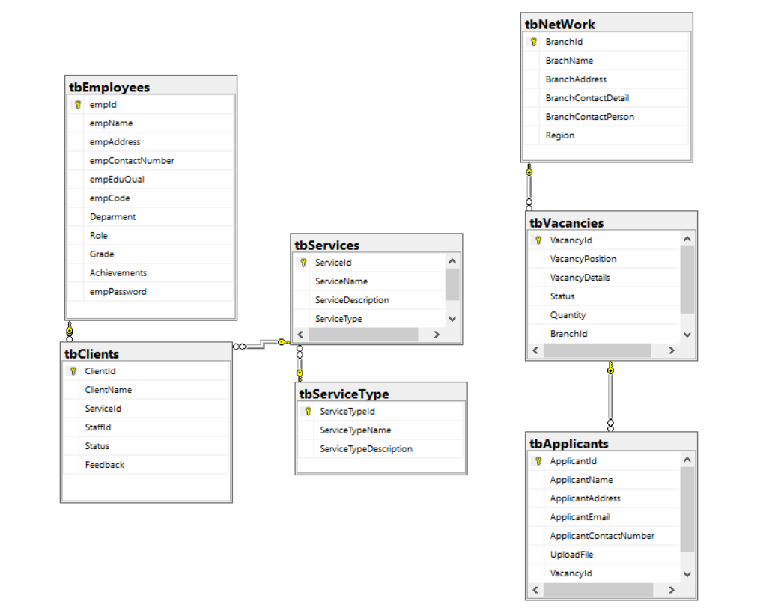

1. **Database Structure**

**2.1. Table Employees Manager**

|  |  |  |  |  |  |  |
| --- | --- | --- | --- | --- | --- | --- |
| Field Name | Data Type | Null | Default | Key | Field-Ref | Description |
| EmpId | int | No |  | PK | Identity(1,1) | EmpId |
| EmpName | nvarchar(50) | No |  |  |  | EmpName |
| EmpAddress | nvarchar(300) | No |  |  |  | EmpAddress |
| EmpContactNumber | int | No |  |  |  | EmpContactNumber |
| EmpEduQual | nvarchar(300) | No |  |  |  | Email |
| EmpCode | nvarchar(50) | No |  |  |  | Name |
| Deparment | nvarchar(50) | No |  |  |  |  |
| Role | int | No |  |  |  |  |
| Grade | int | No |  |  |  | Grade |
| Achievements | Nvarchar(300) | No |  |  |  | Achievements |
| EmpPassword | nvarchar(50) | No |  |  |  | **E**mpPassword |

* 1. **Table Vacancy**

|  |  |  |  |  |  |  |
| --- | --- | --- | --- | --- | --- | --- |
| Field Name | Data Type | Null | Default | Key | Field-Ref | Description |
| VacancyId | int | No |  | PK | Identity(1,1) | VacancyId |
| VacancyPosition | nvarchar(50) | No |  |  |  | VacancyPosition |
| VacancyDetails | nvarchar(300) | No |  |  |  | VacancyDetails |
| Status | bit | No |  |  |  | Status |
| Quantity | int | No |  |  |  | Quantity |
| BranchId | int | No |  |  |  | BranchId |

* 1. **Table Services Type**

|  |  |  |  |  |  |  |
| --- | --- | --- | --- | --- | --- | --- |
| Field Name | Data Type | Null | Default | Key | Field-Ref | Description |
| ServiceTypeId | int | No |  | PK | Identity(1,1) | ServiceTypeId |
| ServiceTypeName | nvarchar(50) | No |  |  |  | ServiceTypeName |
| ServiceTypeDescription | nvarchar(500) | No |  |  |  | ServiceTypeDescription |

* 1. **Table Clients**

|  |  |  |  |  |  |  |
| --- | --- | --- | --- | --- | --- | --- |
| Field Name | Data Type | Null | Default | Key | Field-Ref | Description |
| ClientId | int | No |  | PK | Identity(1,1) | ClientId |
| ClientName | nvarchar(50) | No |  |  |  | ClientName |
| ServiceId | int | No |  |  |  | ServiceId |
| StaffId | int | No |  |  |  | StaffId |
| Status | int | No |  |  |  | Status |
| Feedback | Nvarchar(500) | No |  |  |  | Feedback |

* 1. **Table Services**

|  |  |  |  |  |  |  |
| --- | --- | --- | --- | --- | --- | --- |
| Field Name | Data Type | Null | Default | Key | Field-Ref | Description |
| ServiceId | int | No |  | PK | Identity(1,1) | ServiceId |
| ServiceName | nvarchar(50) | No |  |  |  | ServiceName |
| ServiceDescription | nvarchar(500) | No |  |  |  | ServiceDescription |
| ServiceType | ntext | No |  |  |  | ServiceType |

* 1. **Table NetWord**

|  |  |  |  |  |  |  |
| --- | --- | --- | --- | --- | --- | --- |
| Field Name | Data Type | Null | Default | Key | Field-Ref | Description |
| BranchId | int | No |  | PK | Identity(1,1) | BranchId |
| BrachName | nvarchar(50) | No |  |  |  | BrachName |
| BranchAddress | varchar(50) | No |  |  |  | BranchAddress |
| BranchContactDetail | nvarchar(300) | No |  |  |  | BranchContactDetail |
| BranchContactPerson | nvarchar(300) | No |  |  |  | BranchContactPerson |
| Region | nvarchar(50) | No |  |  |  | Region |

# II – GUI Design

1. **Admin Page**

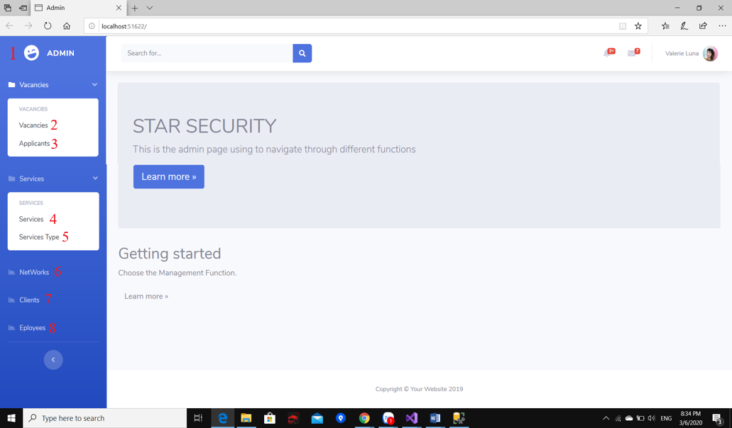

|  |  |  |  |  |  |  |
| --- | --- | --- | --- | --- | --- | --- |
| Admin index | | | | | | |
| No. | **Name** | **Type** | **Validation** | **Event** | **Description** | **Status** |
| 1 | Admin | Hyperlink |  | Click | Index | Enable |
| 2 | Vacancies | Hyperlink |  | Click | Show vacancies list | Enable |
| 3 | Applicants | Hyperlink |  | Click | Show applicants list | Enable |
| 4 | Services | Hyperlink |  | Click | Show services list | Enable |
| 5 | Service Type | Hyperlink |  | Click | Show service type list | Enable |
| 6 | Networks | Hyperlink |  | Click | Show networks list | Enable |
| 7 | Clients | Hyperlink |  | Click | Show clients list | Enable |
| 8 | Employees | Hyperlink |  | Click | Show employees list | Enable |

1. **Clients**

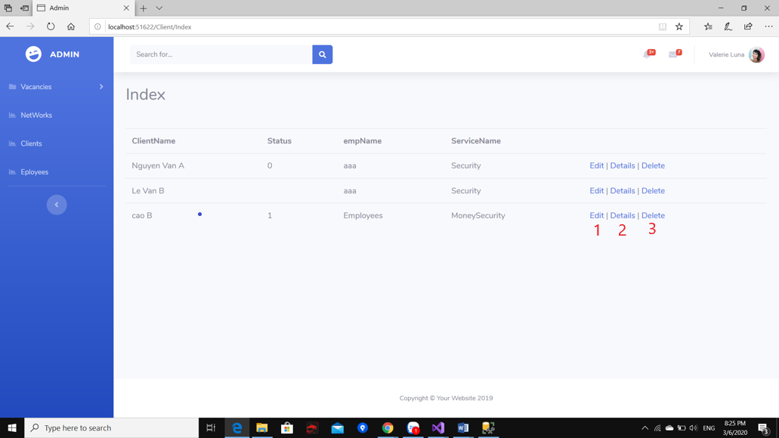

|  |  |  |  |  |  |  |
| --- | --- | --- | --- | --- | --- | --- |
| Clients index | | | | | | |
| No. | **Name** | **Type** | **Validation** | **Event** | **Description** | **Status** |
| 1 | Edit | Hyperlink |  | Click | Edit a client details | Enable |
| 2 | Details | Hyperlink |  | Click | Show a client detail | Enable |
| 3 | Delete | Hyperlink | Check condition if a client has any staff assigned. If it had, can’t delete. | Click | Delete a client | Enable |

1. **Edit A Client:**

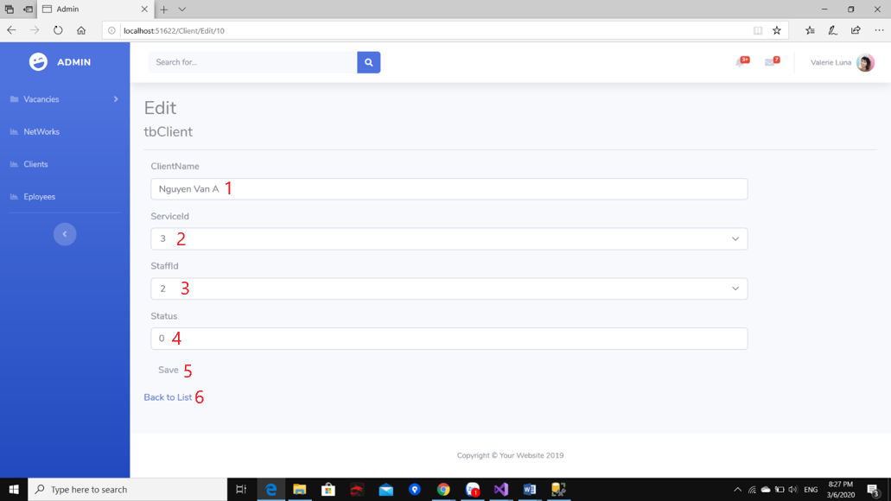

|  |  |  |  |  |  |  |
| --- | --- | --- | --- | --- | --- | --- |
| Edit A Client | | | | | | |
| No. | **Name** | **Type** | **Validation** | **Event** | **Description** | **Status** |
| 1 | Client Name | Textbox | Must have 5-30 normal characters. | Click | Edit a client name | Enable |
| 2 | Service Id | Drop down list | Not null | Click | Edit choosen service | Enable |
| 3 | Staff Id | Drop down list |  | Click | Assign staff (reference from table employee) | Enable |
| 4 | Status | Drop down list | Not null | Click | Update Active/Inactive | Enable |
| 5 | Save | Button |  | Click | Save change to client details | Enable |
| 6 | Back to List | Hyperlink |  | Click | Go back to clients index, discard changes | Enable |

1. **Services**

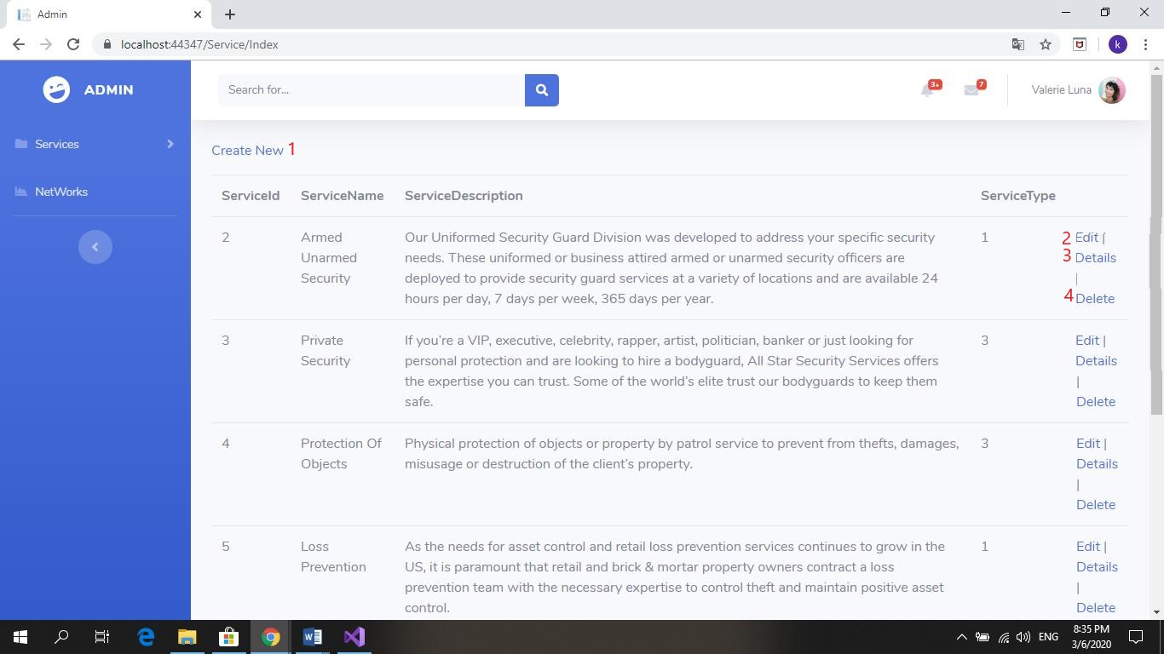

|  |  |  |  |  |  |  |
| --- | --- | --- | --- | --- | --- | --- |
| Services index | | | | | | |
| No. | **Name** | **Type** | **Validation** | **Event** | **Description** | **Status** |
| 1 | Create New | Hyperlink |  | Click | Create new a service | Enable |
| 2 | Edit | Hyperlink |  | Click | Edit a service details | Enable |
| 3 | Details | Hyperlink |  | Click | Show a service detail | Enable |
| 4 | Delete | Hyperlink | Display promp message. Click “Yes” to proceed, “No” to cancel. | Click | Delete a service | Enable |

1. **Edit Services**

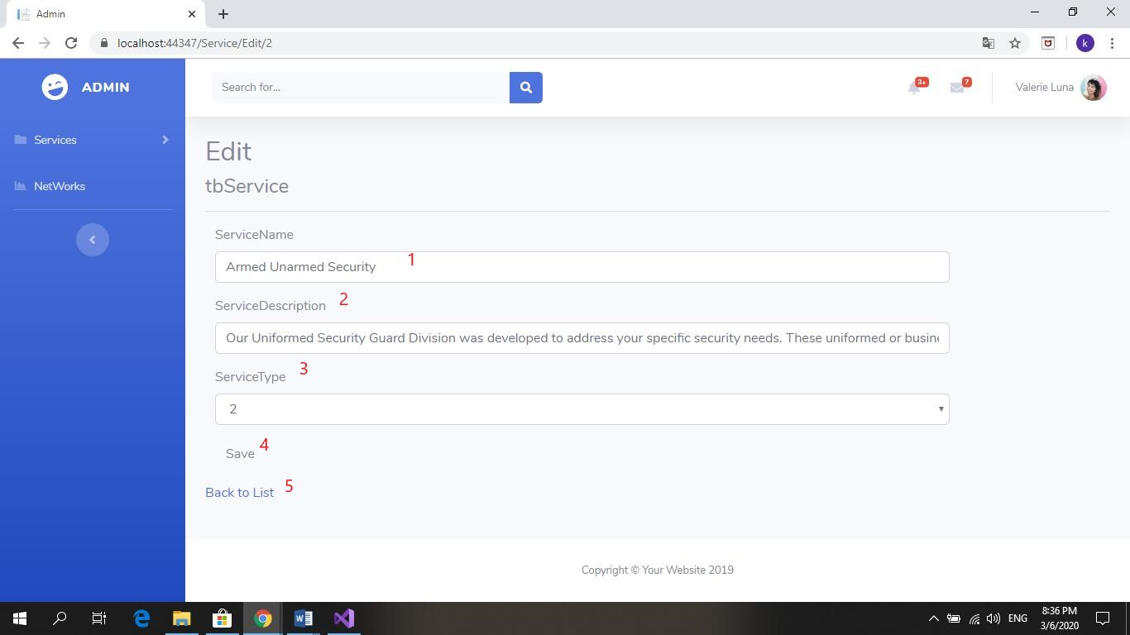

|  |  |  |  |  |  |  |
| --- | --- | --- | --- | --- | --- | --- |
| Edit A Service | | | | | | |
| No. | **Name** | **Type** | **Validation** | **Event** | **Description** | **Status** |
| 1 | Service Name | Textbox | Must have 5-30 normal characters and numbers | Click | Edit a service name | Enable |
| 2 | Service Description | Textbox | Not null | Click | Edit service description | Enable |
| 3 | Service Type | Drop down list |  | Click | Change service type | Enable |
| 4 | Save | Button |  | Click | Save change to service details | Enable |
| 5 | Back to List | Hyperlink |  | Click | Go back to service index, discard changes | Enable |

1. **Create Services**

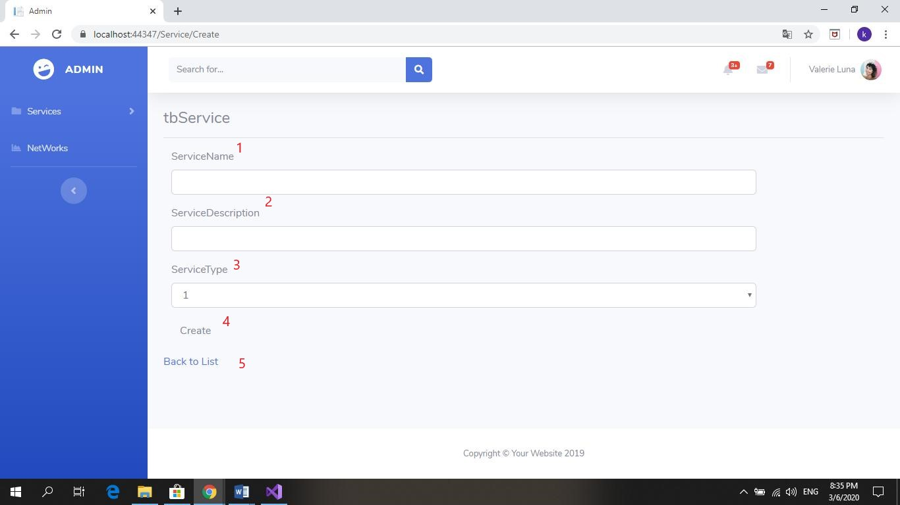

|  |  |  |  |  |  |  |
| --- | --- | --- | --- | --- | --- | --- |
| Create A Service | | | | | | |
| No. | **Name** | **Type** | **Validation** | **Event** | **Description** | **Status** |
| 1 | Service Name | Textbox | Must have 5-30 normal characters and numbers | Click | Create a service name | Enable |
| 2 | Service Description | Textbox | Not null | Click | Create a service description | Enable |
| 3 | Service Type | Drop down list |  | Click | Choose service type | Enable |
| 4 | Create | Button |  | Click | Create new Service | Enable |
| 5 | Back to List | Hyperlink |  | Click | Go back to service index, discard changes | Enable |

1. 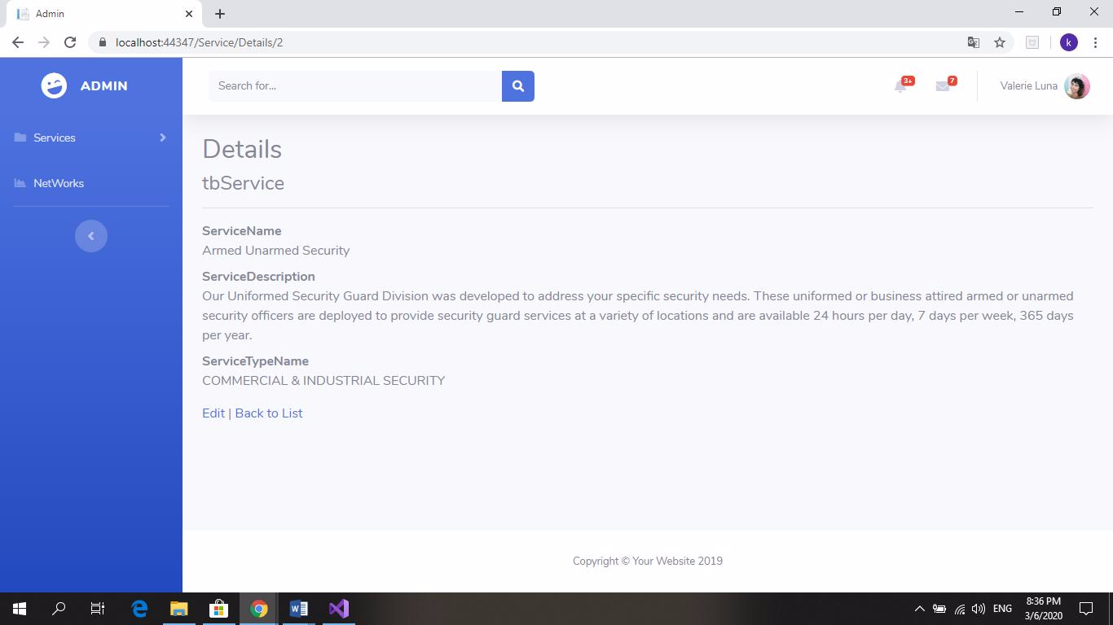**Detail Services:**
2. **Services Type**

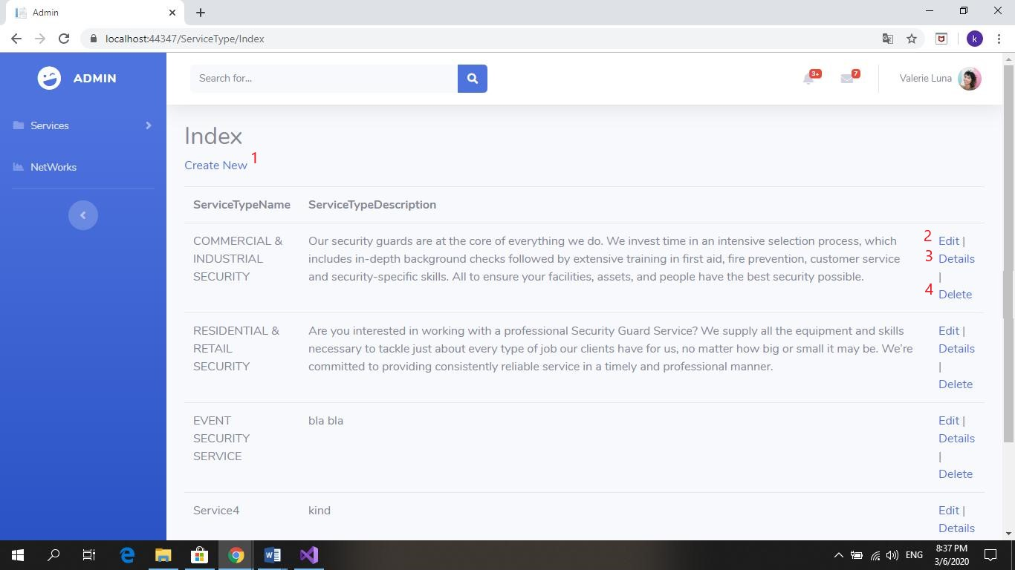

|  |  |  |  |  |  |  |
| --- | --- | --- | --- | --- | --- | --- |
| Services type index | | | | | | |
| No. | **Name** | **Type** | **Validation** | **Event** | **Description** | **Status** |
| 1 | Create New | Hyperlink |  | Click | Create new a service type | Enable |
| 2 | Edit | Hyperlink |  | Click | Edit a service type details | Enable |
| 3 | Details | Hyperlink |  | Click | Show a service type detail | Enable |
| 4 | Delete | Hyperlink | Check if service type has any services. If it had, can’t delete | Click | Delete a service type | Enable |

1. **Create a Service Type**

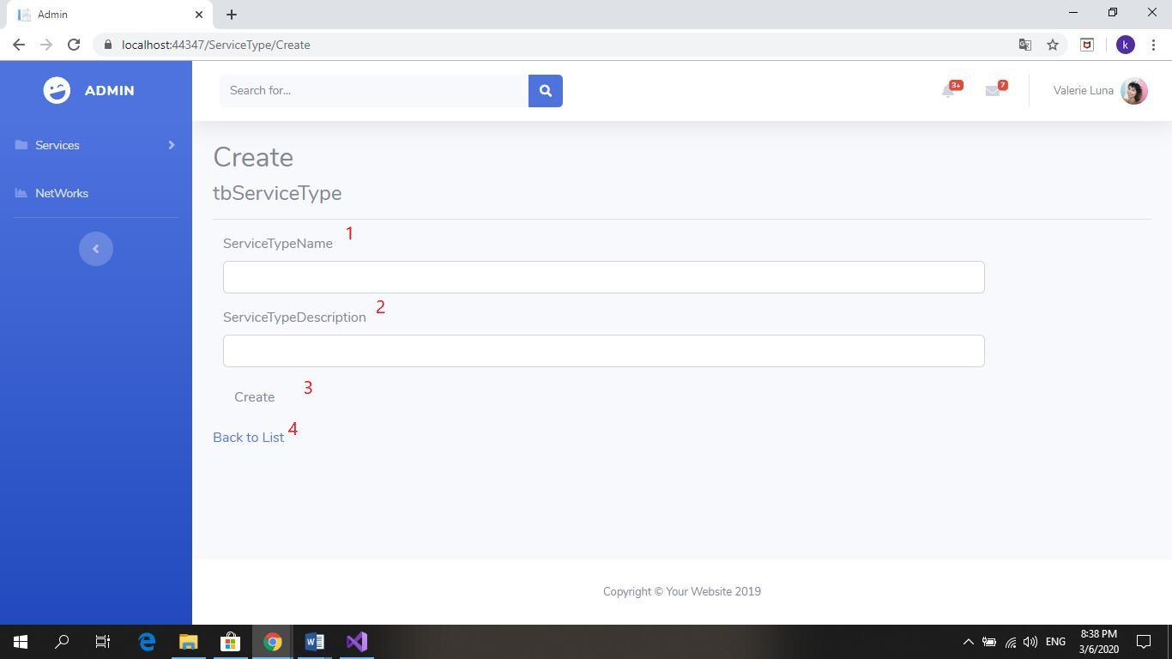

|  |  |  |  |  |  |  |
| --- | --- | --- | --- | --- | --- | --- |
| Create A Service type | | | | | | |
| No. | **Name** | **Type** | **Validation** | **Event** | **Description** | **Status** |
| 1 | Service type Name | Textbox | Must have 5-30 normal characters and numbers | Click | Create a service type name | Enable |
| 2 | Service type Description | Textbox | Not null | Click | Create a service type description | Enable |
| 3 | Create | Button |  | Click | Create new Service type | Enable |
| 4 | Back to List | Hyperlink |  | Click | Go back to service type index, discard changes | Enable |

1. **Detail Services Type**

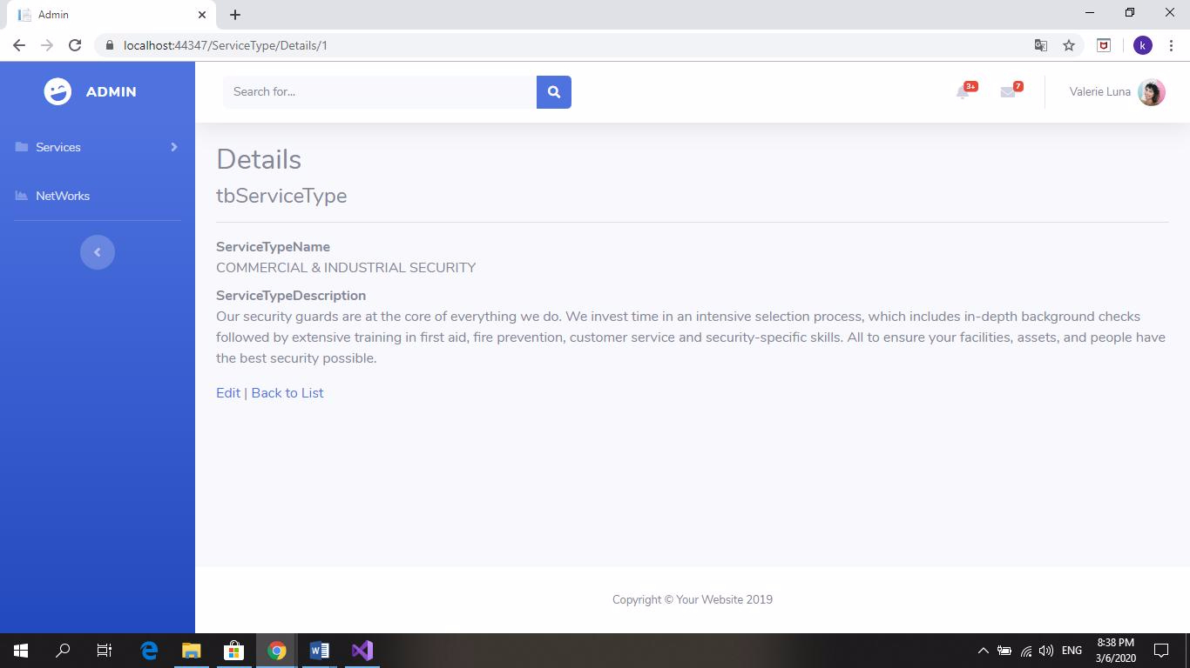

1. **Edit Services Type**

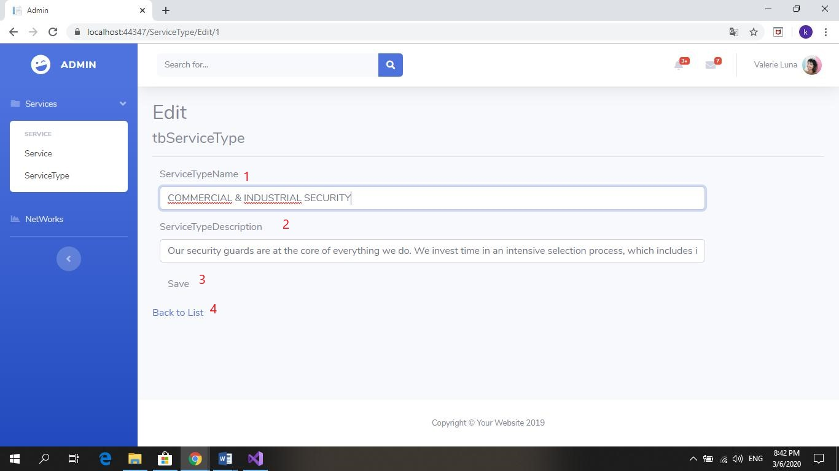

|  |  |  |  |  |  |  |
| --- | --- | --- | --- | --- | --- | --- |
| Edit A Service type | | | | | | |
| No. | **Name** | **Type** | **Validation** | **Event** | **Description** | **Status** |
| 1 | Service type Name | Textbox | Must have 5-30 normal characters and numbers | Click | Edit a service type name | Enable |
| 2 | Service type Description | Textbox | Not null | Click | Edit a service type description | Enable |
| 3 | Save | Button |  | Click | Save changes | Enable |
| 4 | Back to List | Hyperlink |  | Click | Go back to service type index, discard changes | Enable |

1. **Vacancy**

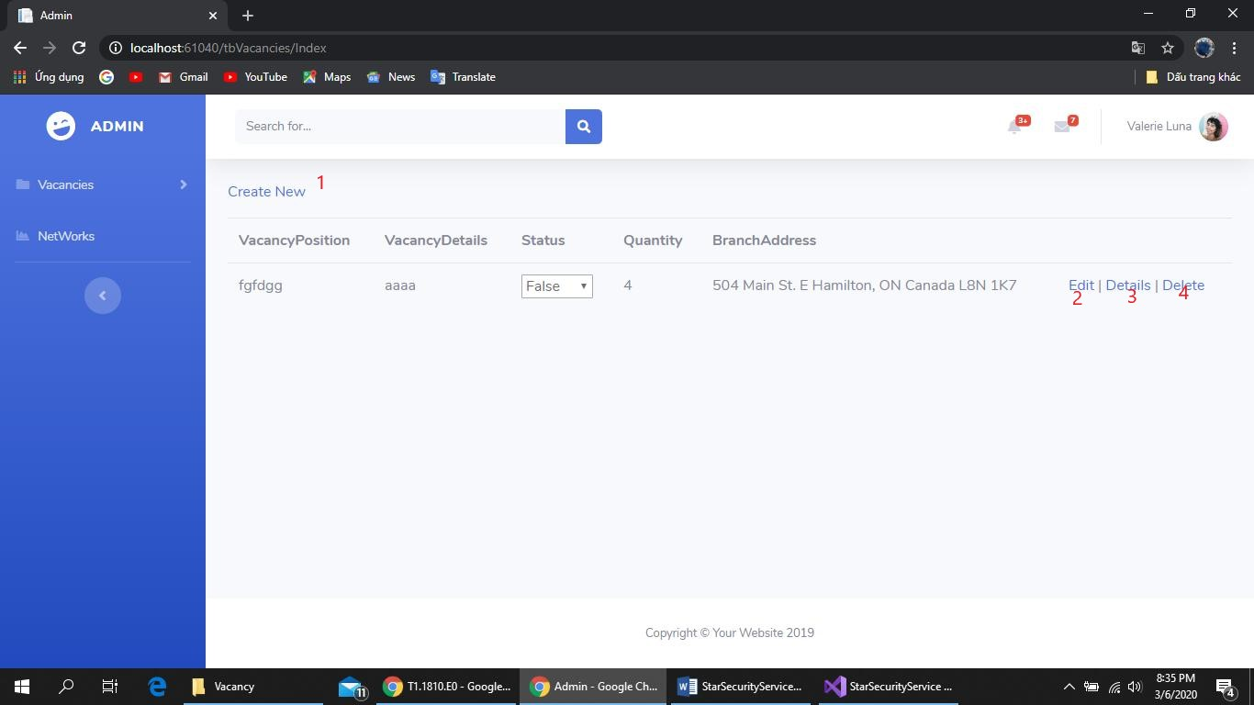

|  |  |  |  |  |  |  |
| --- | --- | --- | --- | --- | --- | --- |
| Vacancy index | | | | | | |
| No. | **Name** | **Type** | **Validation** | **Event** | **Description** | **Status** |
| 1 | Create New | Hyperlink |  | Click | Create new a vacancy | Enable |
| 2 | Edit | Hyperlink |  | Click | Edit a vacancy details | Enable |
| 3 | Details | Hyperlink |  | Click | Show a vacancy detail | Enable |
| 4 | Delete | Hyperlink | Check if a vacancy has any applicants or status is true. If it had, can’t delete | Click | Delete a vacancy | Enable |

1. **Create Vancancy**

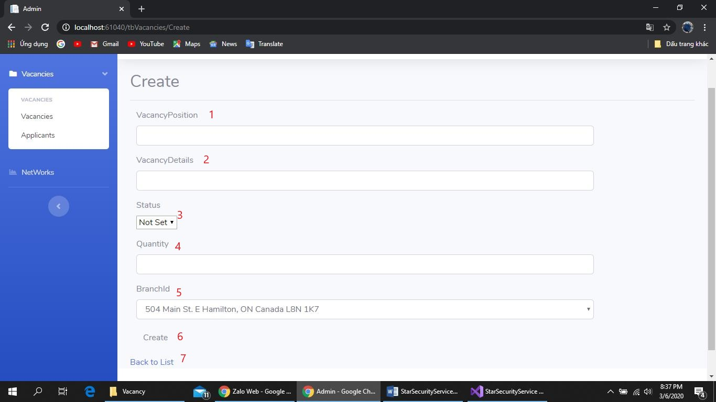

|  |  |  |  |  |  |  |
| --- | --- | --- | --- | --- | --- | --- |
| Create A vacancy | | | | | | |
| No. | **Name** | **Type** | **Validation** | **Event** | **Description** | **Status** |
| 1 | Vacancy Position | Textbox | Must have 5-30 normal characters and numbers | Click | Create a new vacancy position | Enable |
| 2 | Vacancy Details | Textbox | Not null | Click | Create a vacancy detail | Enable |
| 3 | Status | Drop down list |  | Click | Choose “Active/Inactive” status | Enable |
| 4 | Quantity | Textbox | Not null | Click | Input number of vacancy of this position | Enable |
| 5 | Branch Id | Drop down list | Not null | Click | Select which branch offer this position | Enable |
| 6 | Create | Button |  | Click | Create new vacancy | Enable |
| 7 | Back to List | Hyperlink |  | Click | Go back to vacancy index, discard changes | Enable |

1. **Edit a Vacancy**

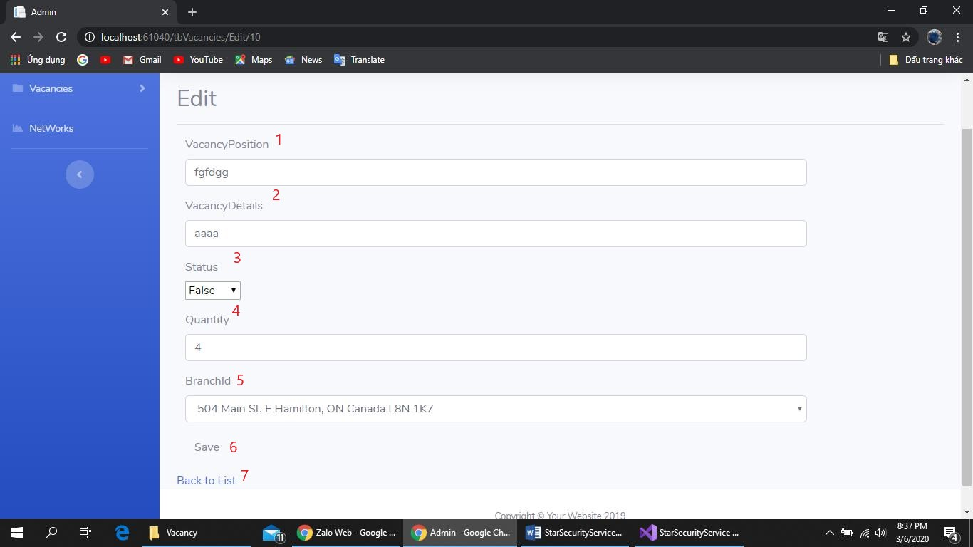

|  |  |  |  |  |  |  |
| --- | --- | --- | --- | --- | --- | --- |
| Edit A vacancy | | | | | | |
| No. | **Name** | **Type** | **Validation** | **Event** | **Description** | **Status** |
| 1 | Vacancy Position | Textbox | Must have 5-30 normal characters and numbers | Click | Edit a vacancy position | Enable |
| 2 | Vacancy Details | Textbox | Not null | Click | Edit a vacancy detail | Enable |
| 3 | Status | Drop down list |  | Click | Choose “Active/Inactive” status | Enable |
| 4 | Quantity | Textbox | Not null | Click | Change number of vacancy of this position | Enable |
| 5 | Branch Id | Drop down list | Not null | Click | Select which branch offer this position | Enable |
| 6 | Save | Button |  | Click | Save Changes | Enable |
| 7 | Back to List | Hyperlink |  | Click | Go back to vacancy index, discard changes | Enable |

1. Details Vacancy

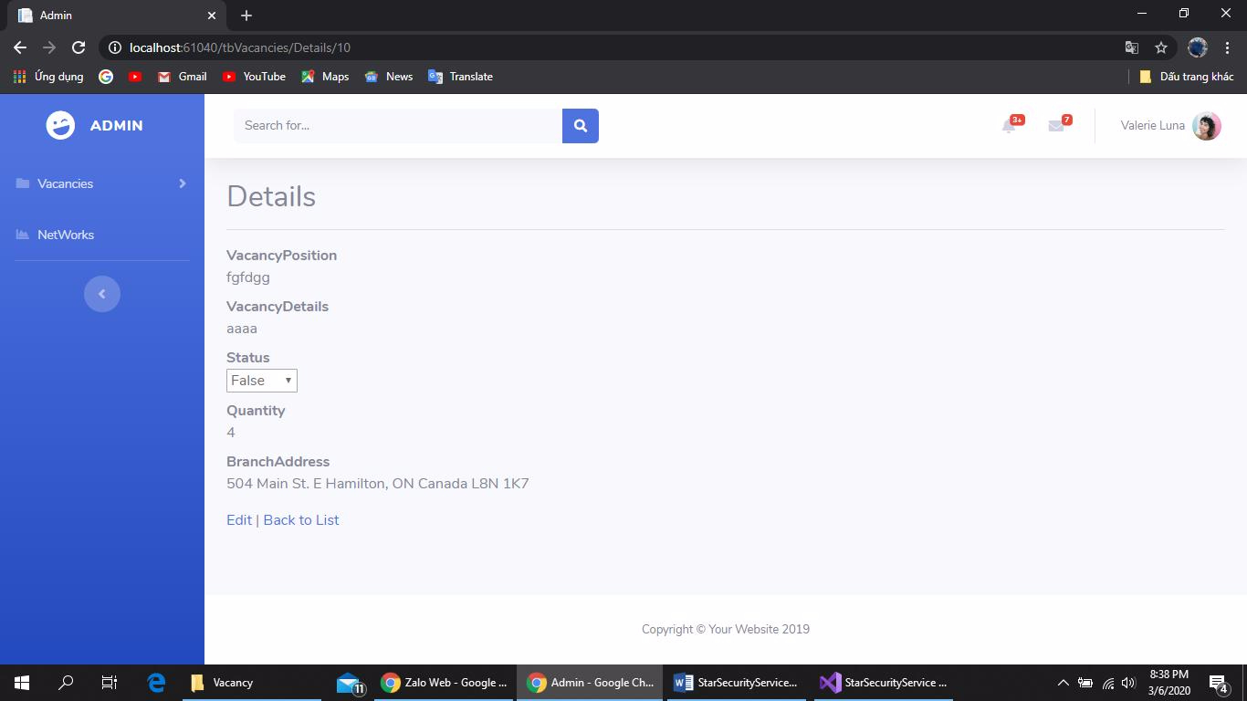

1. Network

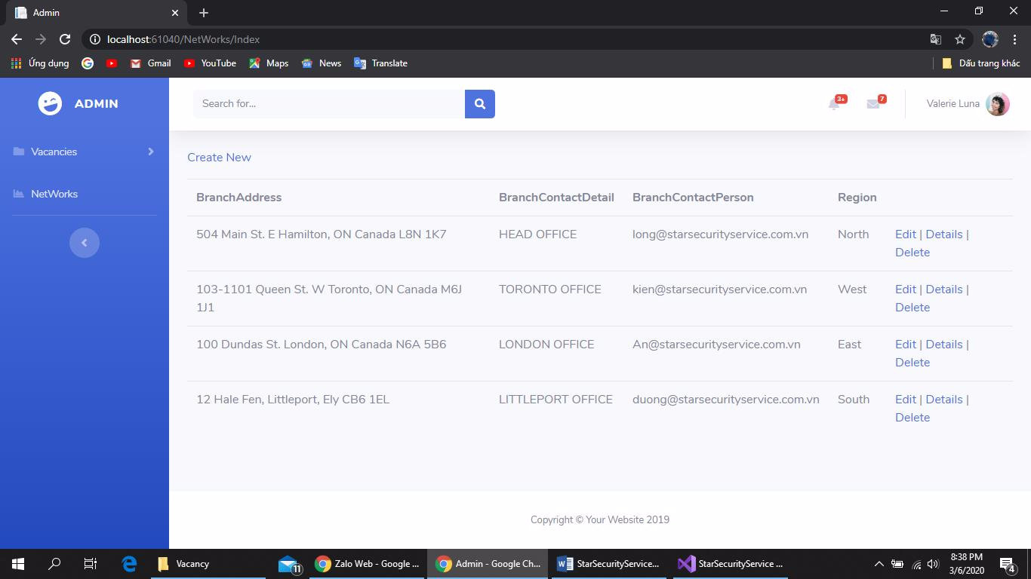

1. 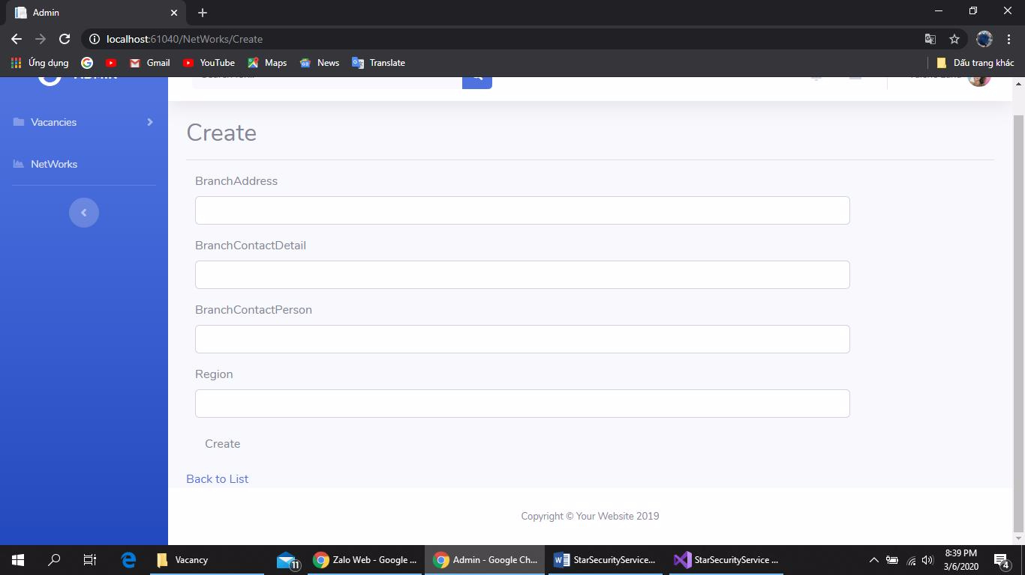 **Create Network**
2. **Edit Network**

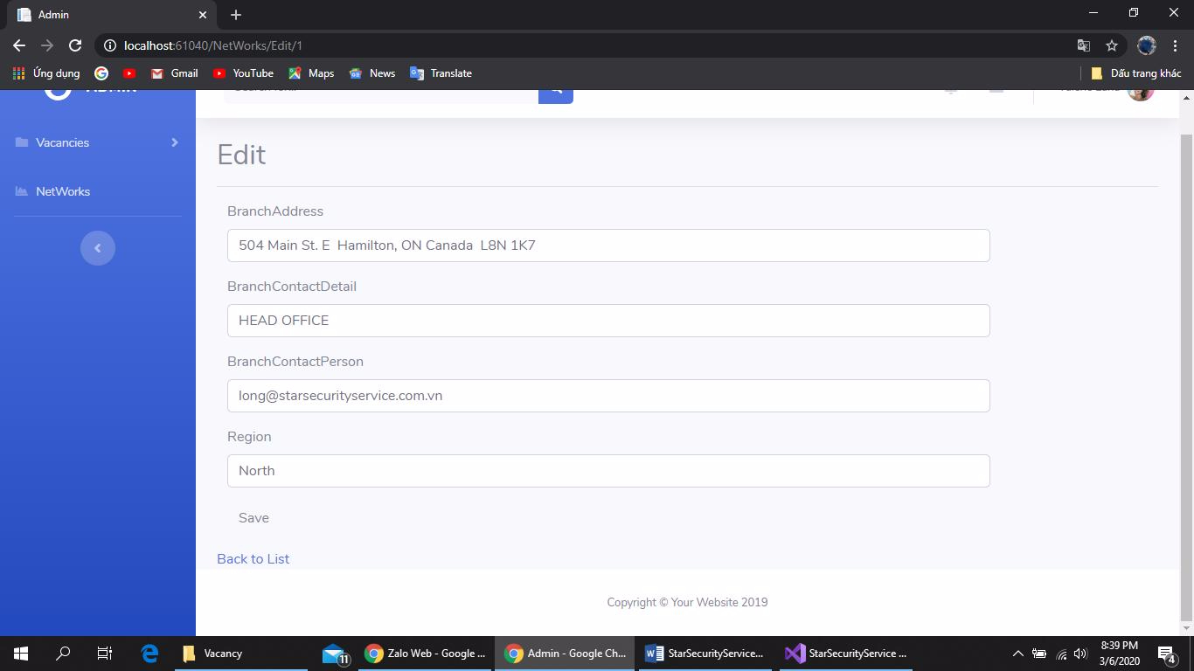

1. **Detail Network**

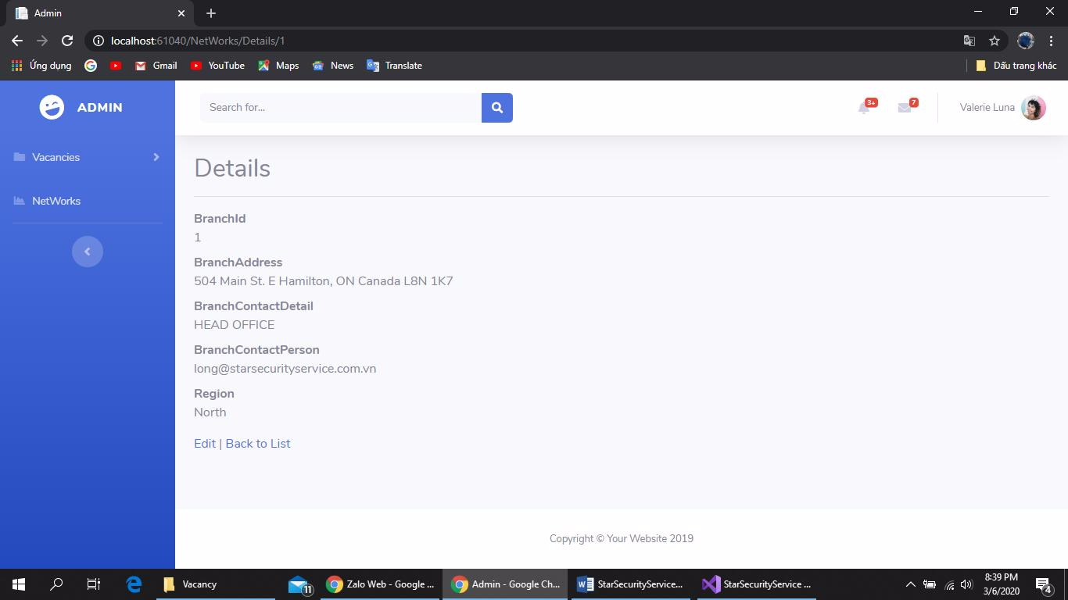

1. **Applicants**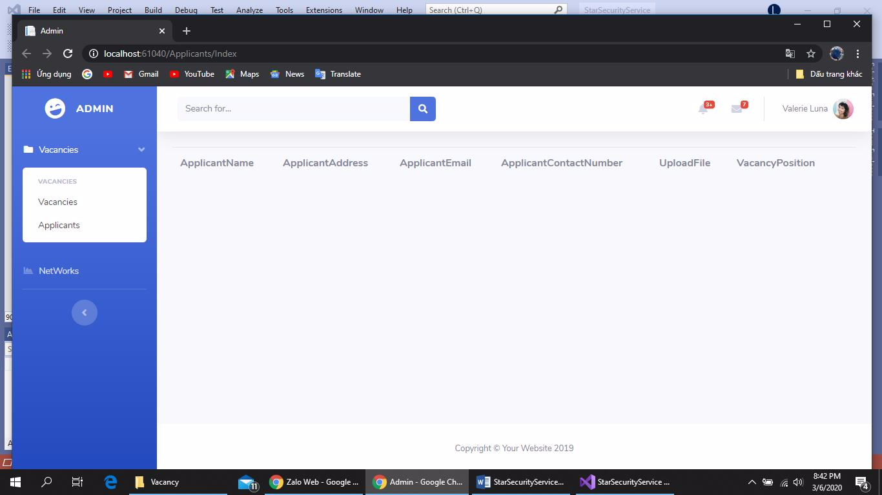
2. **Employees**

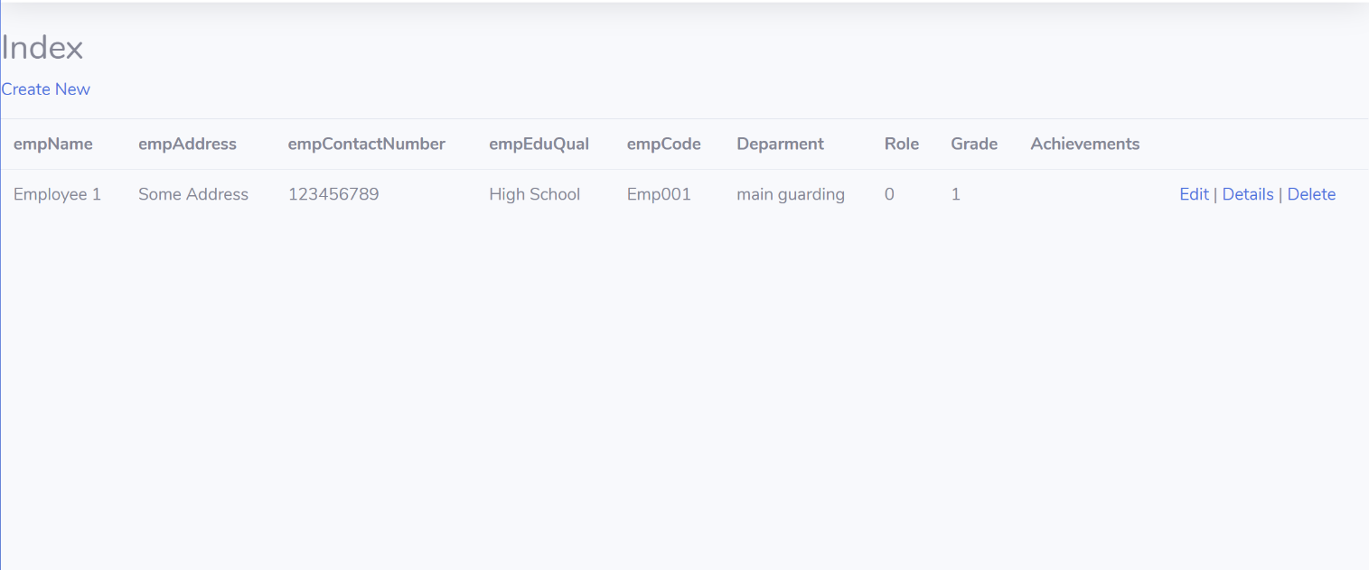

|  |  |  |  |  |  |  |
| --- | --- | --- | --- | --- | --- | --- |
| Employee index | | | | | | |
| No. | **Name** | **Type** | **Validation** | **Event** | **Description** | **Status** |
| 1 | Create New | Hyperlink |  | Click | Create new an employee | Enable |
| 2 | Edit | Hyperlink |  | Click | Edit an employee | Enable |
| 3 | Details | Hyperlink |  | Click | Show an employee detail | Enable |
| 4 | Delete | Hyperlink | Check if a employee has any clients. If it had, can’t delete | Click | Delete a employee | Enable |

1. **Create an employee**

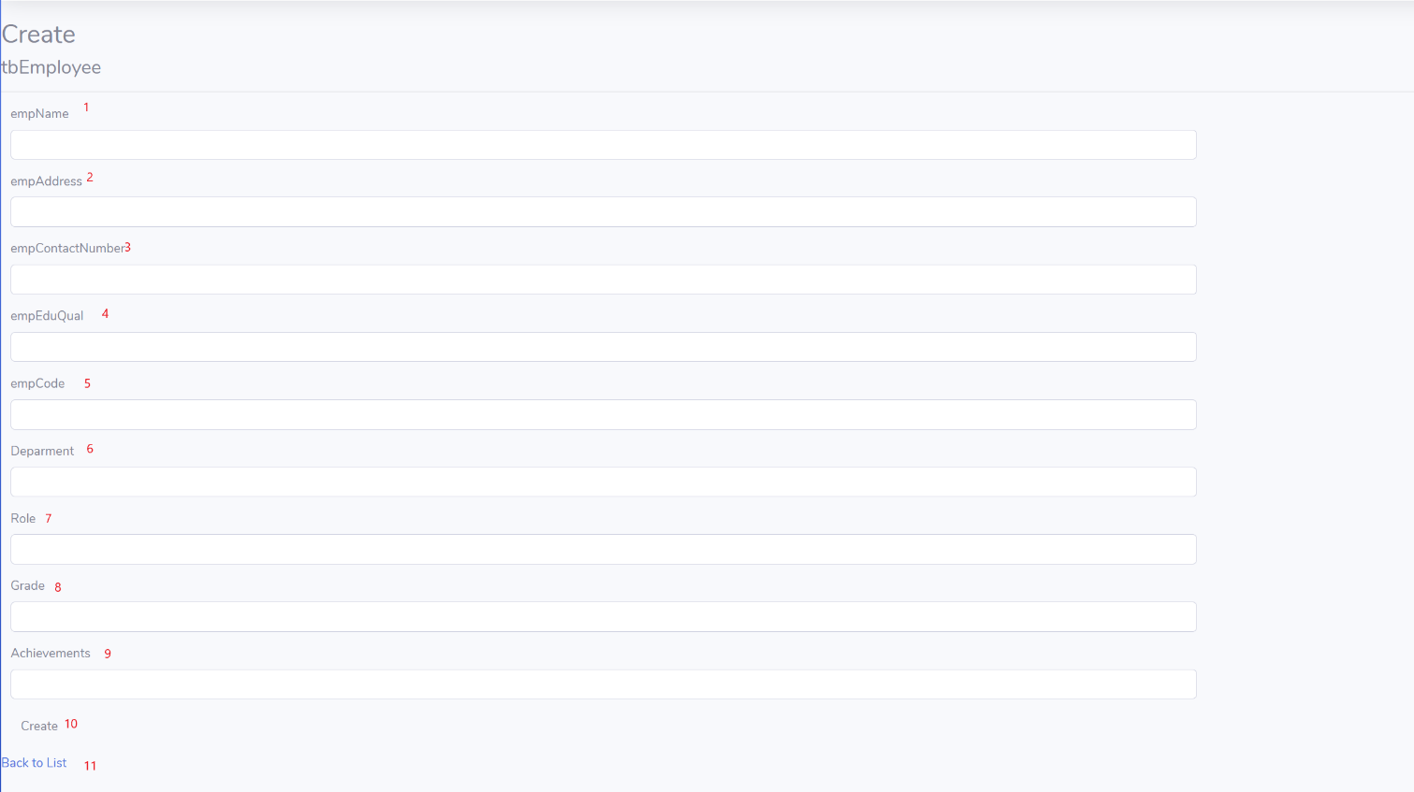

|  |  |  |  |  |  |  |
| --- | --- | --- | --- | --- | --- | --- |
| Create An employee | | | | | | |
| No. | **Name** | **Type** | **Validation** | **Event** | **Description** | **Status** |
| 1 | Employee Name | Textbox | Must have 5-30 normal characters. | Click | Create a new employee name | Enable |
| 2 | Employee Address | Textbox | Not null | Click | Create a employee address | Enable |
| 3 | Employee Contact number | Textbox | Numbers only | Click | Create a employee contact number | Enable |
| 4 | Employee education qualification | Textbox | Not null | Click | Input employee education qualification | Enable |
| 5 | Employee Code | Textbox | Not null | Click | Input employee code | Enable |
| 6 | Department | Textbox | Not null | click | Input department |  |
| 7 | Role | Drop down List |  | Click | Assign role for employee |  |
| 8 | Grade | Textbox | Not null | Click | Input employee grade |  |
| 9 | Achievements | Textbox |  | Click | Input employee achievements (if any) |  |
| 10 | Create | Button |  | Click | Create new employee | Enable |
| 11 | Back to List | Hyperlink |  | Click | Go back to employee index, discard changes | Enable |

1. **Edit an Employee**

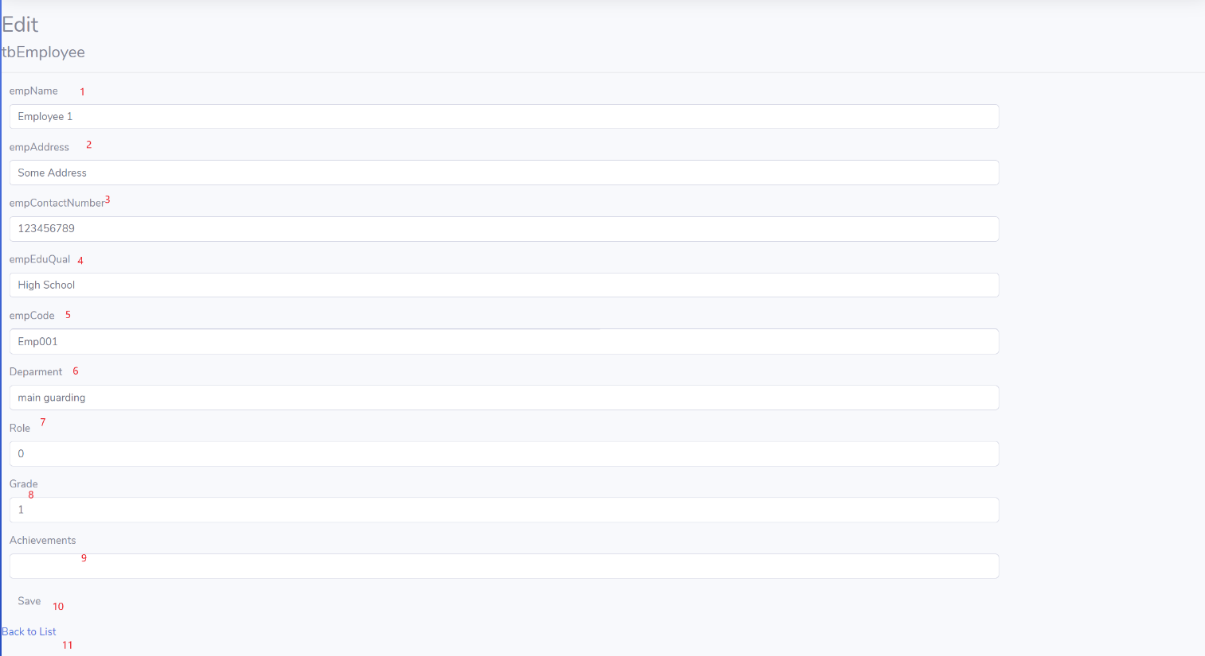

|  |  |  |  |  |  |  |
| --- | --- | --- | --- | --- | --- | --- |
| Edit An employee | | | | | | |
| No. | **Name** | **Type** | **Validation** | **Event** | **Description** | **Status** |
| 1 | Employee Name | Textbox | Must have 5-30 normal characters. | Click | Edit an employee name | Enable |
| 2 | Employee Address | Textbox | Not null | Click | Edit a employee address | Enable |
| 3 | Employee Contact number | Textbox | Numbers only | Click | Edit a employee contact number | Enable |
| 4 | Employee education qualification | Textbox | Not null | Click | Input employee education qualification | Enable |
| 5 | Employee Code | Textbox | Not null | Click | Input employee code | Enable |
| 6 | Department | Textbox | Not null | click | Input department |  |
| 7 | Role | Drop down List |  | Click | Assign role for employee |  |
| 8 | Grade | Textbox | Not null | Click | Input employee grade |  |
| 9 | Achievements | Textbox |  | Click | Input employee achievements (if any) |  |
| 10 | Save | Button |  | Click | Save change | Enable |
| 11 | Back to List | Hyperlink |  | Click | Go back to employee index, discard changes | Enable |

# 

# Task Sheet Review III

|  |  |  |  |  |  |
| --- | --- | --- | --- | --- | --- |
| Project Ref. No: 3 | Project Title:  Star Security Service | Date of Preparation of Activity Plan | | | |
| No. | Task | Actual Start Date | Actual Days | Team Member Names | Status |
| 01 | Database Diagram | Mar-02, 2020 | 5 | Le Huu An | Completed |
| 02 | Database Structure | Completed |
| 03 | * Clients list. * Edit clients details * Delete client * View Clients details. * NetWork List * Edit NetWork details * Delete NetWorks * View Networks details | Cao Dang Xuan Duong | Completed |
| 04 | * Login. * Logout. * Authentication * Admin index. * Employee list. * Create new Employee. * Edit Employee. * Employee details. * Delete Employee. | Le Huu An | Completed |
| 05 | * Vacancy list. * Create new Vacancy. * Edit Vacancy. * Vacancy details. * Delete Vacancy. * Applicant List * Edit applicants * Delete applicants | Nguyen Hai Long | Completed |
| 06 | * Services list. * Create new Service. * Edit Service. * Service details. * Delete Service. * Service type list. * Edit Service type * Delete Service type | Nguyen Dinh Kien | Completed |

|  |  |  |
| --- | --- | --- |
|  | Prepare By: Group 1 | Approved By: Faculty |
| Date: Mar-06, 2020 | Team Leader  Le Huu An | Mr. Hoang Duc Quang |